PLEASE POST

Dear Members of the NU Community,

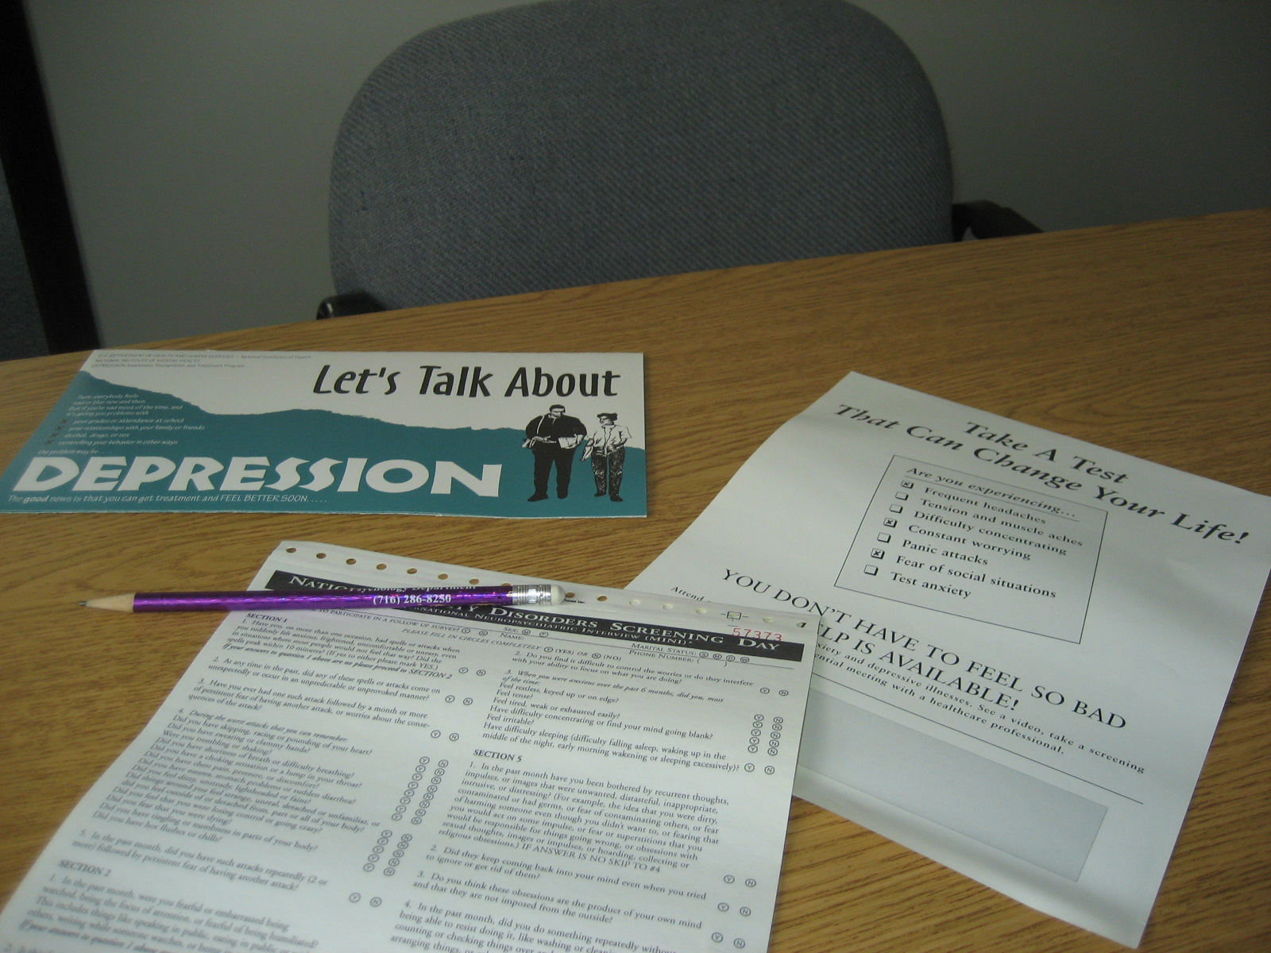
Thursday, October 10th, is National Depression Screening Day. The National Institute of Mental Health recognizes depression as an ever-increasing health problem in the United States, with a lifetime prevalence of nearly 20%. In addition, several recent reports suggest that rates of psychological problems, including depression, are on the rise among college students. The good news is that nearly 80% of people with clinical depression can be treated successfully.

The Department of Psychology, Health Services, and Counseling Services at Niagara University, in conjunction with the Mental Health Association in Niagara County, will offer a free and confidential depression screening on that day. The screening also assesses the possible presence of bipolar disorder, post-partum depression, anxiety, and posttraumatic stress. Students, staff members, and local community residents may go to one of three sites to obtain the screening.

Dr. Tim Osberg of the Psychology Department, along with Lori Soos, Director of Health Services, Monica Romeo, Director of Counseling Services, and members of Active Minds at Niagara (a student run campus mental health awareness organization), will conduct screenings in the Clinical Psychology Laboratory Complex in DePaul Hall, Room 135, at Niagara from 12-6 p.m.

The screening will involve anonymous administration of a brief questionnaire. For those concerned about a relative or friend, numerous informative brochures will be available. Referrals will be provided. A video on depression and related disorders will be shown continuously.

Further information about the depression screening may be obtained by calling Dr. Osberg at Niagara (extension 8524) or the Mental Health Association in Niagara County at 433-3780.

