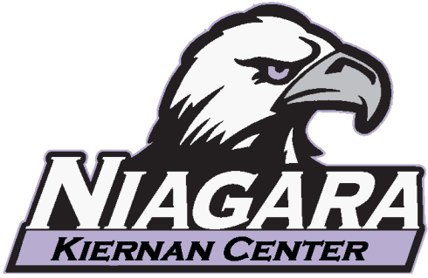
From The Desk of Danny Riggi, CPT, CSCS
Fitness and Operations Coordinator
driggi@niagara.edu 716.286.8055
Hello Purple Eagles,
Welcome to the Niagara University Kiernan Center! Whether you are a new or continuing member you are an important part of our fitness center and to the surrounding Niagara University community.
My name is Danny Riggi and I am privileged to serve as your Fitness and Operations Coordinator. My main priority is to focus my leadership on creating a healthy, safe and inclusive fitness environment where you can maximize your personal potential while pursuing a healthier and fulfilling lifestyle that will benefit you for years to come.
FITNESS ON A PROFESSIONAL LEVEL
As an employee or faculty member of Niagara University your access to the Kiernan Center’s Professional Health and Wellness Program is important to us. Employee wellness programs have been proven to decrease stress, reduce employee absenteeism, decrease the risk of onsite injury, and increase overall productivity. After an individual consultation which includes an in depth health screening and relevant fitness testing, a small group fitness program which includes resistance training, nutritional guidance, and cardio planning is carefully crafted and designed to fit the group’s professional needs and fitness goals. Exclusive seminars and workshops will also be offered throughout the academic year for professional members only. Education and gradual progress is the key to success in any fitness program and knowing the most up to date research is critical in your training. This is where I can help you. As the Fitness and Operations Coordinator my responsibilities are to ensure that you fulfill your fitness goals and to provide encouragement and guidance every step along the way. Here is a list of my certifications:
- American College of Sports Medicine (ACSM) Certified Personal Trainer
- National Strength and Conditioning Association (NSCA) Certified Strength and Conditioning Specialist
- American Academy of Sports Dietitians and Nutritionists (AASDN) Nutrition Specialist
- World Instructors Training School (WITS) Cardio Kickboxing instructor
- DSW Fitness Core Conditioning Specialist and Plyometric Specialist
I invite you to ask any questions that you may have at any time and welcome you to explore the personal training options that are available to you here at the Kiernan Center.
Best wishes for an extraordinary experience here at the Kiernan Center, and GO PURPLE EAGLES!
Danny Riggi, CPT, CSCS
Fitness and Operations Coordinator

