WE NEED YOU… to visit the CRL 101 Poster Presentations!

CRL 101 students will present posters on Thursday, Nov. 21. Please come to one, two or all three classes to chat with students about the posters they created
about these high-interest books.
This project can’t succeed without visitors. All are invited!

Three classes will be presenting:

Section A: 9:40 – 11:00 am
Section B: 11:10 am – 12:30 pm
Section C: 2:10 – 3:30 pm

All presentations are in MPR (Multipurpose Room), Gallagher Center.

First They Killed My Father by Loung Ung. The author was a child during the brutal Khmer Rouge regime in Cambodia in the 1970s.

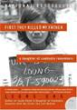

Warriors Don’t Cry by Melba Patillo Beals. The author, one of the “Little Rock Nine,” describes the harrowing 1957-1958 school year.

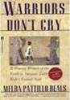

A Long Way Gone: Memoirs of a Boy Soldier by Ishmael Beah. The author was forced to become a child soldier in Sierra Leone’s civil conflict in the 1990s.
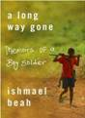

Letters from the End of the World by
Toyofumi Ogura. In one of the few first-
hand accounts of the atomic bombing of
Hiroshima in 1945, the author grieves his
wife’s death by recounting his experience in
the aftermath of the bombing.

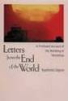

Dear Zari: The Secret Lives of the Women of Afghanistan by Zarghuna Kargar. The author interviewed women for her popular radio program “Afghan Women’s Hour.” Dear Zari contains 13 of these stories depicting the lack of rights for Afghan women.

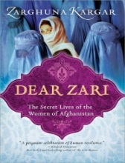

For more information, contact Sharon Green at 716-286-8071 or sgreen@niagara.edu.

