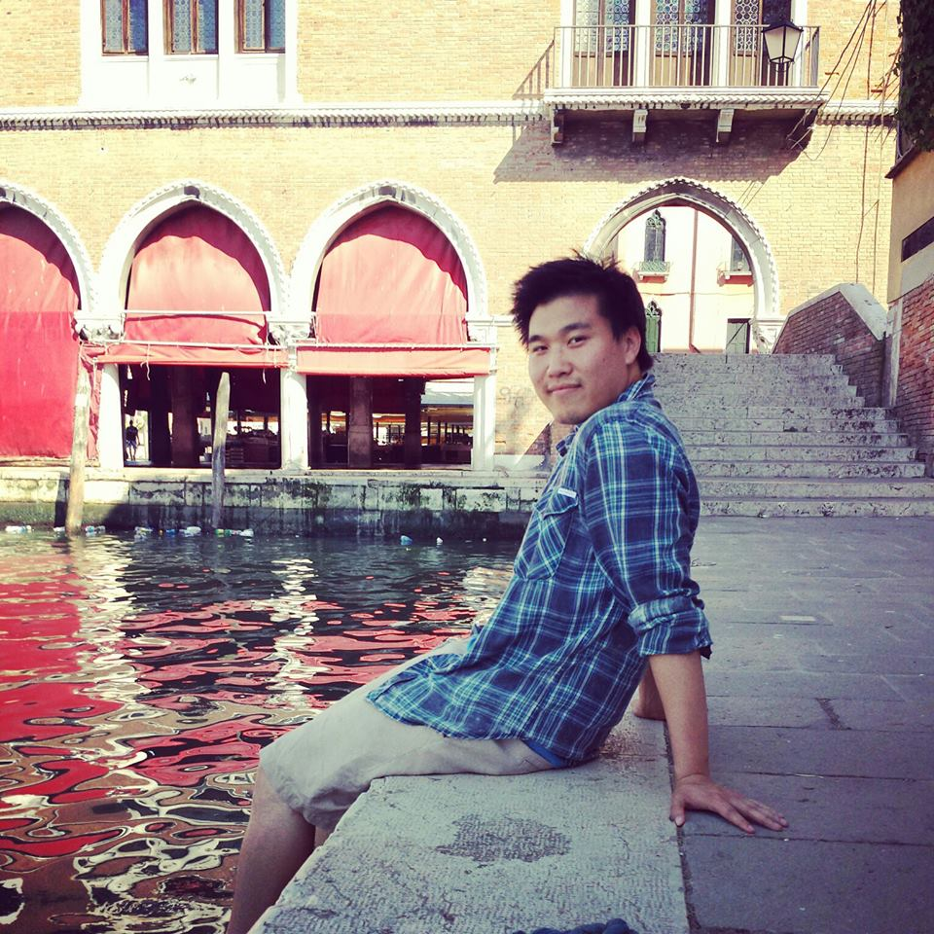

Matthew Thompson (716) 425-0940

Matthew Faso (716) 550-0558

Gabrielle Licastro (716) 957-2788

Remi Gonzalez (716) 622-5354

Please join Andy’s family & friends to support them

Sunday December 1st at St. John De LaSalle

8477 Buffalo Ave. Niagara Falls, NY 14304

2pm-6pm & Dinner from 3pm-5pm

Tickets are $20 per person (includes spaghetti dinner & 1 sheet of auction tickets) – There will also be live entertainment.

Raffle items, basket donations, gift certificates, baked goods and all other donations are greatly appreciated!

Pick up/drop off arrangements can be made by contacting any of the following:

## Join us as we celebrate his life and help his family defray medical expenses, lawyer fees, and college debt.

Kiran Kandola (716) 930-8050

Ashley Scibilia (716) 946-9588

Michael Ciraolo (716) 425-9669

## At a young age of 22, Aiden “Andy” Liu passed away August 7th, 2013 from injuries suffered from a fall.

**Benefit For Andy Liu**