DESCRIPTION OF REGISTRATION HOLDS
Below you will see the various hold types and information on how to resolve them:
“RG” – Registration Hold: (STUDENT ACCOUNTS OFFICE – 716-286-8300)
Student has a tuition account balance, which may reflect pending aid. To view their current online statement with the current semester’s pending aid, the student needs to login into 'WebAdvisor', click on 'Financial Information' and 'Current Account Statement'. The balance must be paid prior to registration.
“IN” – Incomplete File Hold: (ADMISSIONS OFFICE 716-286-8700)
The student is missing something that is required in their permanent file. The student should contact the Admissions Office to determine what documentation is outstanding.
“HE” or “ME” – Health Services Holds: (HEALTH SERVICES 716-286-8390)
The student’s Health Services file is incomplete. The student must contact the Health Services office for details. They may just need to sign a form.
“LO”- Loan Hold: (STUDENT ACCOUNTS OFFICE – 716-286-8300)
The student needs to complete information for their Perkins Loan by going to www.signmyloan.com and complete their Master Promissory Note and/or Entrance Interview.
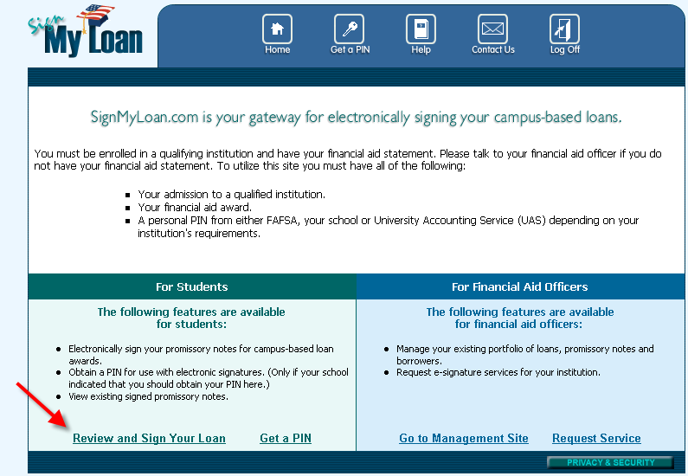
“FV”- Verification Hold: (FINANCIAL AID OFFICE 716-286-8686)
For a Verification hold, the student may need to supply the Financial Aid Office with certain documents to disburse their aid. They should Log into WebAdvisor, click on ‘My Documents’ and see if there are forms needed to disburse the aid. If the student needs to submit a Federal Verification Worksheet, it can be found at www.niagara.edu/financialaid. Click on FAQ, Docs & Info, and then Documents & Links and locate the correct form on the right-hand side. The student should print the “Dependent worksheet” if they are a dependent of their parents or print the “Independent worksheet” if they are an independent student. If they or their parents need to complete the IRS Data Retrieval, they would go back to www.fafsa.ed.gov and make a correction to the FAFSA. The address must be an exact match to what is on the tax forms.

“FN”- Entrance Interview Hold: (FINANCIAL AID OFFICE 716-286-8686)
The student needs to complete the Entrance Counseling for their Federal Direct Loan. This online counseling session will take approximately 30 minutes to complete. The borrower must complete the counseling session in one sitting in order for it to be recorded in the system.
Go to Studentloans.gov to complete the Entrance Counseling. The student will need their FAFSA PIN number in order to sign in. After the student signs in, they can select “Complete Entrance Counseling”. Be sure to complete all of the steps before submitting the form.
Please contact the Financial Aid office with any questions – 716-286-8686
“IL” - Direct Loan Promissory Note Hold: (FINANCIAL AID OFFICE 716-286-8686)
The student needs to complete his/her Master Promissory Note for their Federal Direct Loan. Go to StudentLoans.gov and click on "Sign In". Students will need their FAFSA PIN number in order to sign in. After they sign in, they should click on "Sign Master Promissory Note" and choose the Subsidized/Unsubsidized option. Be sure to complete all off the steps before submitting the form. The student’s name MUST match exactly to what is on the FAFSA.
Within a few days, the student will receive a confirmation e-mail from the Financial Aid Dept. If you don't, please contact us.
If they have any questions, they can call the Financial Aid Office at 716-286-8686.
“IP” - Federal Plus Loan Promissory Note Hold: (FINANCIAL AID OFFICE 716-286-8686)
The students’ parent needs to complete the Master Promissory Note for the Federal Plus Loan. The parent can go to Studentloans.gov to complete this. Parents should sign into the website with their FAFSA PIN number, and their information. Once the parent signs in, they should select Complete Master Promissory Note and choose Parent Plus Loan. They must complete all of the steps before submitting the form. The student’s name MUST match exactly what is on the FAFSA and parents MUST use their full legal name. Initials are not allowed because they will reject.
If you have any questions, call the Financial Aid Office at 716-286-8686
“IG” – Federal Grad Plus Loan Promissory Note Hold: (FINANCIAL AID OFFICE 716-286-8686)
The student needs to complete his/her Master Promissory Note for their Federal Direct Loan. Go to StudentLoans.gov and click on "Sign In". Students will need their FAFSA PIN number in order to sign in. After they sign in, they should click on "Sign Master Promissory Note" and select Complete Master Promissory Note and choose the Graduate Plus Loan.
“NS” – Nursing Self-Certification Form: (Student Accounts 716-286-8300) Nursing students awarded a Nursing Student Loan must complete the Self Certification form and send it to the Student Accounts Office to have the loan disbursed.
“SF” – Self-Loans –WILL NEVER STOP REGISTRATION IT IS ONLY A REPORTING MECHANISM.
REVISED 10/03/13

