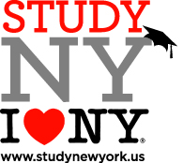

Study New York 2nd Annual Member Meeting
June 24, 2015
Niagara University, New York
St. Vincent’s Hall, rm. 405-406

9:30 am Arrival, registration and coffee
10:00 am Welcome
10:10 am Construction of an Education USA Program – Jody Lehr Waite, Associate Director of International Outreach, Rochester Institute of Technology
10:30 am Organization Update - Study NY Board
10:50 am Updates from US Commercial Service Buffalo Representative
11:00 am Member Introductions/Comments/Suggestions
12:00 pm Working lunch involving small group discussions
1:00 pm Small groups report out
1:30 pm Best Practices for Working with Agents Panel including:
Caroline Levesque of ICEF Montreal
Mary Marquez Bell, VP of Enrollment Services, SUNY Old Westbury & Past President of AIRC
Ward Deutschman, Communications Director, Study New York

2:30 pm Closing remarks - Maria Conzatti, Study New York Chair
2:45 pm Castellani Art Museum Tour

