Middle Eastern and Islamic Studies Fall 2015
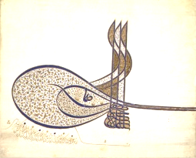
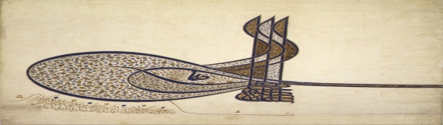
Film Series
All movies will be shown in Dunleavy 127 @7 pm – Open to All – Free Refreshments – Post-film Discussion
9/15/2015 | 1913: Seeds of Conflict
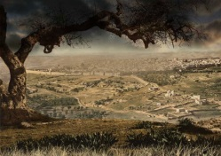 | A PBS documentary on the pre-WWI origins of the Arab-Israeli conflict. It looks at the moment of transformation when Ottoman rule in Palestine was still strong, the identities of Jerusalemites were fluid and few could imagine the conflict that would dominate the region for the next century. Breaking new ground, this film focuses on the moment just before World War I, when Arab and Jewish nationalism first made contact, and the seeds of conflict were first sown.
9/29/2015 | Muhammad: Legacy of a Prophet
 | An exceptional PBS documentary on the life of the Prophet of Islam with episodes on how everyday American Muslims experience his legacy in the post-9/11 context.
10/20/2015 | Children of Heaven
 | A 1997 Iranian family drama film. Represents the renaissance of Iranian film. After a boy loses his sister's pair of shoes, he goes on a series of adventures in order to find them. When he can't, he tries a new way to "win" a new pair.
10/27/2015 | Cities of Light: The Rise and Fall of Islamic Spain
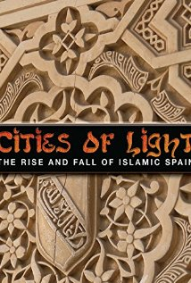 | Over a thousand years ago, the sun-washed lands of Southern Spain were home to Muslims, Christians, and Jews living together and flourishing. Their culture and beliefs intertwined and the knowledge of the ancients was gathered and reborn. Here were the very seeds of the Renaissance. But this world too quickly vanished. Within a few centuries, the fragile union of these people dissipated like smoke. This documentary explores the causes that destroyed the one civilization of pluralism and interfaith cooperation that for a few centuries lit the Dark Ages in Medieval Europe.
11/3/2015 | Kingdom of Heaven
 | Directed by Ridley Scott, starring Orlando Bloom and Eva Green, this historical drama depicts a French blacksmith's defense of Jerusalem against Saladin during the Crusades of the 12th century.
11/10/2015 | Encounter Point
 | A feature documentary that follows a former Israeli settler, a Palestinian ex-prisoner, a bereaved Israeli mother and a wounded Palestinian bereaved brother who risk their lives and public standing to promote a nonviolent end to the Arab-Israeli conflict. The film explores what drives them and thousands of other like-minded civilians to overcome anger and grief to work for grassroots solutions.
11/17/2015 | Mystic Iran
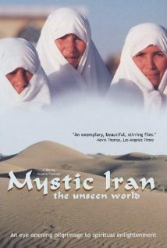 | Explores practices rarely if ever seen on film before. Shot entirely on location, this unprecedented cinematic tour reveals spiritual rites and rituals hidden for centuries. From the women's chamber of the Great Mosque, to the temple-caves in the land of Zarathustra, to the sacred dance of the Dervishes in Kurdistan, discover religious ceremonies and locations never before seen by the outside world.
12/1/2015 | Inside Islam: What a Billion Muslims Think
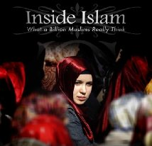 | This film explores the expertly gathered opinions of Muslims around the globe as revealed in the world’s first major Muslim opinion poll, conducted by Gallup. Gallup researchers began by asking the questions on every American’s mind. Why is there so much anti-Americanism in the Muslim world? Who are the extremists and how do Muslims feel about them? What do Muslims like and dislike about the West? What do Muslim women really want? Focused on the issues of Gender Justice, Terrorism, and Democracy –the film presents this remarkable data deftly, showing how it challenges the popular notion that Muslims and the West are on a collision course.

