Susan B. Anthony Birthday Celebration

Wednesday, February 10, 2016

6:00 P.M. – 7:00 P.M., BIS 351

Welcome by Dr. Tim Ireland,
Dean of the College of Arts & Sciences
Dr. Shannon Risk, Assistant Professor of History, discusses Susan B. Anthony
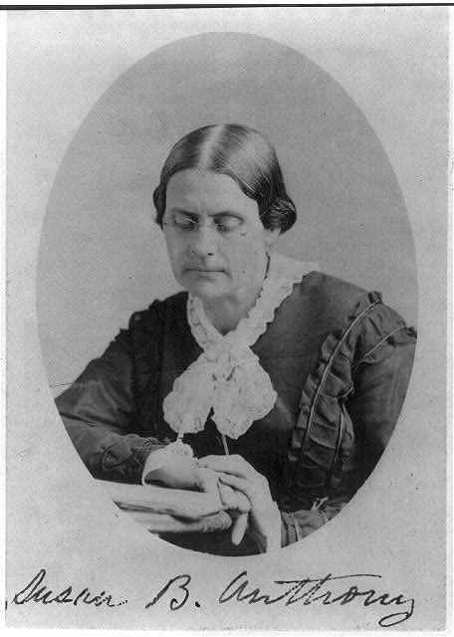
Sharon Green, Coordinator of Instructional Services, Office of Academic Support, introduces the Susan B. Anthony Writing Awards
Dr. Joseph Little, Associate Professor of English, introduces Sara Anderson
Award winner Sara Anderson describes her paper “Jane Eyre: Feminist of the Victorian Era”

Susan B. Anthony was born on February 15, 1820.
Enjoy some birthday cake to celebrate her 196th birthday!

Learn more about Susan B. Anthony at http://susanbanthonyhouse.org/her-story.php

