Niagara Catholic Jr. / Sr. High School
Grades 7-12

“Welcome to the Family”

- Announces -

- Graduate as a 1st Semester College Sophomore –
“Save a year of college tuition”

- 5 Full Academic Scholarships for one year available for the 2016/17 school year

- Additional Scholarships available for years 2, 3, and 4

- Check out the details at www.niagaracatholic.org

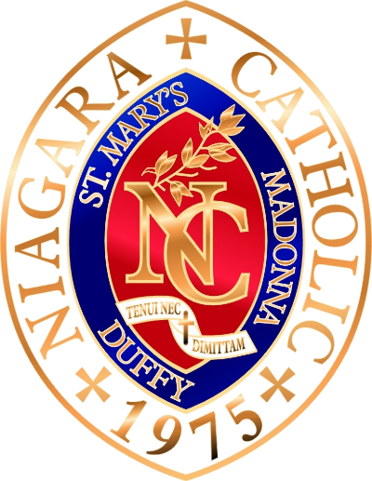

(5) 1 year academic scholarships available to new students entering NC as H.S. Freshman
– details on website –
Academic Scholarships
For 2016 – 2017

(5) 1 year academic scholarships for 2016/17 school year

Criteria as follows:

- Enter as a new student
- Enter as a H.S. Freshman
- Have a 95% grade average in 7/8 grade
- Be involved in church
- 3 reference letters
- Write an essay “Why do I want to attend Niagara Catholic,” and “Why education is important to me.”
- Scholarship committee will make final selection
- Additional scholarship available for years 2, 3, and 4
- Savings value $8,500 plus 1st year of college tuition
- Application, report cards, reference letters, and essay due to:
Niagara Catholic Jr. / Sr. High School
520 – 66th Street, Niagara Falls, NY 14304
Or, by email to: sowen@niagaracatholic.org by April 15, 2016
- Questions call admissions at 283-8771 ext. 260

