LECTURE -- “Empowering Women in Rural Tanzania”

Featuring Rasel Madaha, US Fulbright Fellow, 2009 to 2012, University at Buffalo
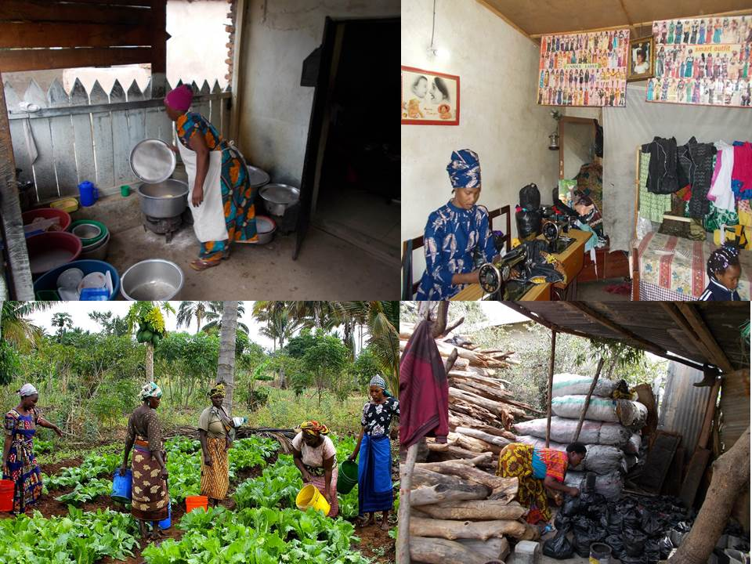

Saturday, June 25, 2016 ** 4:00 – 5:00 p.m. ** 17 Norton, University at Buffalo

** To learn more about our not-for-profit project associated with women’s empowerment, please visit www.agentz.org

Directions from the I-290 going toward Amherst:
Take Exit 4, which is the I-990. Then take Exit 1, which is the University exit.
Exit 1 will bring you to Audubon Parkway. Immediately move to the left lane, and make a U-turn just before the signal light at Audubon and Rensch. Move immediately to the right lane and take the first exit, which is White Road. Watch for the Governors Parking Lot on your right. It’s after you pass the intersection at White and Hadley Roads. There are signs that say, “Visitors Parking.” Pull up to the gates and tell the attendant you are on campus for an event. I will make sure the attendant has what he/she needs to allow you to park in the visitor’s lot free of charge. Ask the attendant to direct you to Capen Hall.
Upon entering Capen Lobby (this is the ground floor) walk past the café and down the hall toward the left. Down this hallway Capen Hall turns into Norton Hall. Follow the brick flooring until you see a lime green wall. This is 17 Norton. You will see a sign indicating you’ve reached The Academies.
University at Buffalo Campus Map [North Campus]: http://www.buffalo.edu/buildings/maps/NorthCampus.pdf

RSVP to Shannon Risk at: srisk@niagara.edu.

