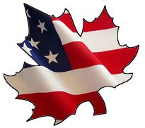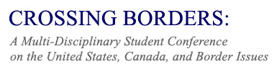
March 17-18, 2017, Niagara University
Deadline for Abstracts: February 20, 2017

CONFERENCE HIGHLIGHTS
Friday, March 17
- Opening reception
- Keynote Address: Dr. Kevin White, Assistant Professor of Native American Studies, SUNY-Oswego, and Fulbright Visiting Scholar, Brock University, fall 2017.

Saturday, March 18
- Panel presentations and workshops with undergraduate and graduate students from Canada and the United States.
- Luncheon for conference participants.

CALL FOR PAPERS
Abstracts due February 20, 2017
- Abstracts should be 250 words or less.
- Full papers are due at conference. For those students who wish to be considered for the Crossing Borders Best Paper Award, submission of full paper is due on March 1, 2017.
- Papers should be 10-15 pages in length.

Suggested topics for the conference include, but are not limited to the following:
* Canada and U.S. Trade and Business * Educational Policies
* Canadian-American Relations * Tourism and Transportation
* Canada and U.S. Border Security * The Border in Art and/or Literature
* Canada and U.S. Immigration Policies * Canada and U.S. Energy Policies
* Cross Border Crime and Policing * Popular Culture and Mass Media
* Comparative Elections * Communication & Cultural Policy
* Environment and Boundaries * Canadian-U.S. Literacy Studies
* Indigenous Peoples * History of Border Regions

Please submit your abstract and contact information, including full name, university, level of study and program, to Dr. Shannon Risk, Associate Professor of History at Niagara University at srisk@niagara.edu.

