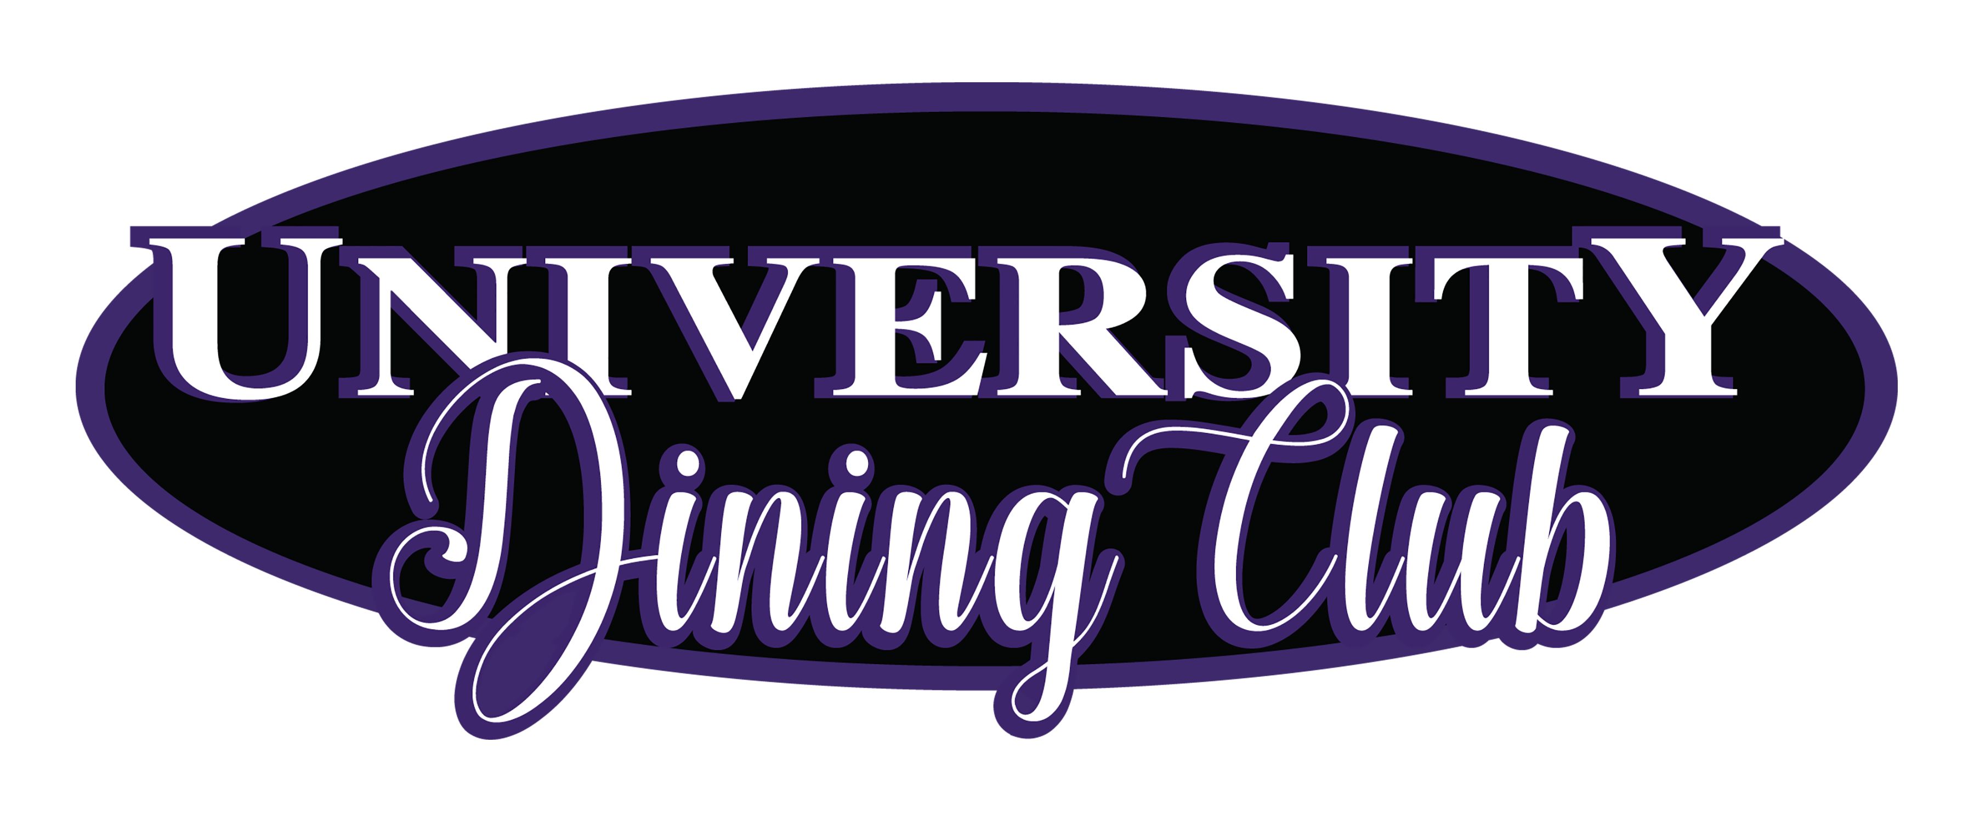
October 17th -21st 2016
Chef’s sandwich combinations, with choice of soup or salad

OPTION 1
Chicken Waldolf Sandwich
Shaved Chicken, Diced Red Apples, Chopped Walnuts, Dried Craisins and Butter Lettuce on Raisin Bread
Grilled Vegetable Hoagie
Balsamic Marinated Zucchini, Squash, Red Pepper, Asparagus topped with a Goat Cheese Aioli on Grilled Sourdough Bread

Served with your choice
Featured homemade soup of the day or seasonal market salad

House made Chips
_____________
OPTION 2: Bowl of today’s homemade soup with rustic Baguette

Spinach Salad topped with Warm bacon mustard dressing

OPTION 3: Lunch Entree Plates
(Select One)
Chicken Saltimbocca
Sliced grilled chicken, fontina, prosciutto, sage, pesto on grilled Ciabatta Roll
Philly Cheesesteak
Grilled peppers, onions and provolone cheese topped with roasted garlic Aioli
Pasta Bolognese
Meat Sauce topped with Shaved Parmesan and Garlic Toast
Catch of the Day, inquire with server

All above selections are lunch-sized portions, served with a complimenting
Chef’s choice of garnish, House made chips or vegetable where applicable

Add a small salad or cup of soup to the lunch entrée plates for 1.25

(In the quest for expedited service, no substitutions please on menu selections)

Seasonal fruited water, iced tea, coffee and hot tea are included
$7.00 Inclusive of Tax

Alternative Beverages
Can of soda 1.25 - Bottle Soda 1.75 – Mineral Water 1.75

OPTION 4: The Commons Buffet
Is also available for your enjoyment. Notify your server that you are going to select from the Commons Buffet
where you can serve yourself from the expanded selection of food and beverage offered daily
$10.25 inclusive of Tax

