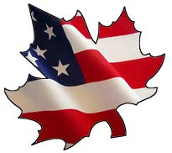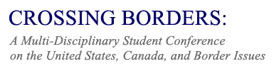
March 16-17, 2018, Brock University
Deadline for Abstracts: February 19, 2018

CONFERENCE HIGHLIGHTS
Friday, March 16
- Opening reception
- Keynote Address: Dr. Daniel J. Broyld, History Department, Central Connecticut State University and Fulbright Research Chair in Transnational Studies, Brock University.

Saturday, March 17
- Panel presentations and workshops with undergraduate and graduate students from Canada and the United States.
- Luncheon for conference participants.

CALL FOR PAPERS
Abstracts due February 19, 2018
- Abstracts should be 250 words or less.
- Full papers are due at conference. For those students who wish to be considered for the Crossing Borders Best Paper Award, submission of full paper is due on March 1, 2018.
- Papers should be 10-15 pages in length.

Suggested topics for the conference include, but are not limited to the following:
* Canada and U.S. Trade and Business * Educational Policies
* Canadian-American Relations * Tourism and Transportation
* Canada and U.S. Border Security * The Border in Art and/or Literature
* Canada and U.S. Immigration Policies * Canada and U.S. Energy Policies
* Cross Border Crime and Policing * Popular Culture and Mass Media
* Comparative Elections * Communication & Cultural Policy
* Environment and Boundaries * Canadian-U.S. Literacy Studies
* Indigenous Peoples * History of Border Regions

Please submit your abstract and contact information, including full name, university, level of study and program, to Dr. Marian Bredin, Director, Centre for Canadian Studies, Brock University: mbredin@brocku.ca

