Time and Attendance Employees’ “First Day” Guide
- Go to https://workforcenow.adp.com
- Click on User Login and enter your current User ID/Password, then click Login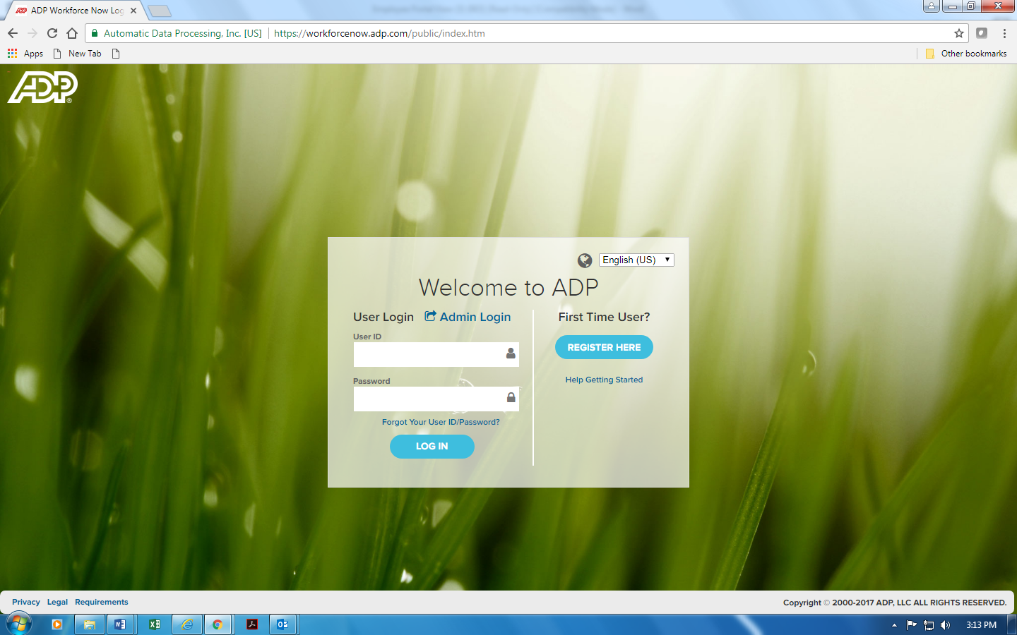

You will be brought to your company’s Home screen. (Screen may look different due to your company’s preferences)

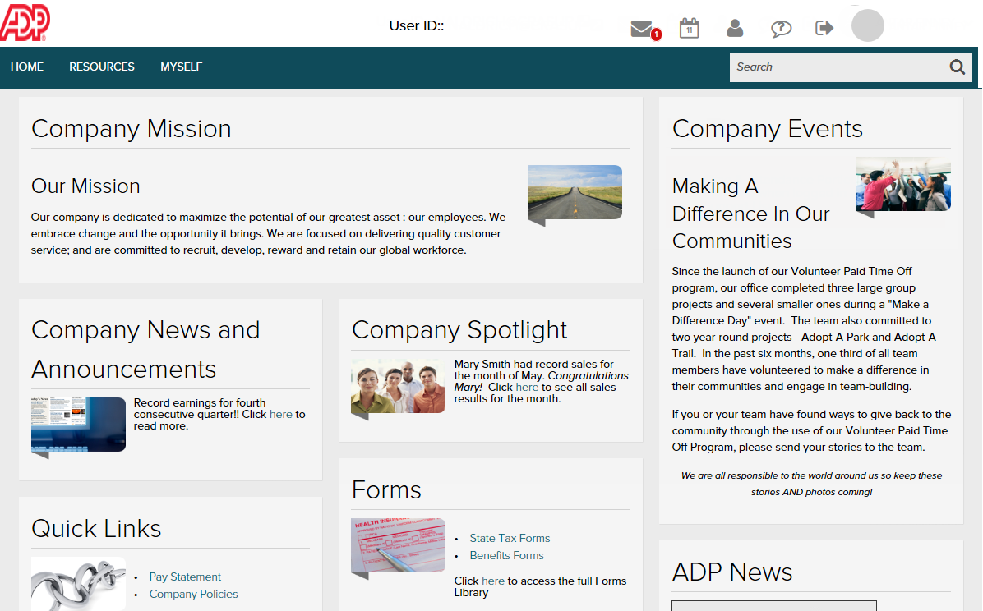

- Click on (1) Tab-(2)Time and Attendance-(3)My Time Entry

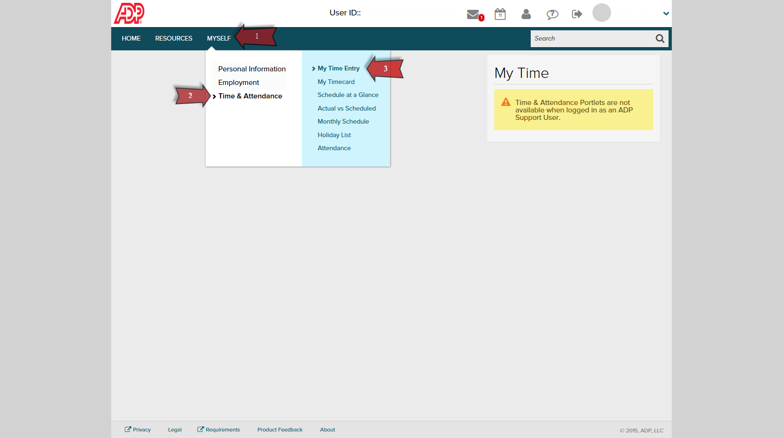

- Select Clock In, Clock Out, or My Timecard to log in your time. (This screen may vary based on Employees’ position)

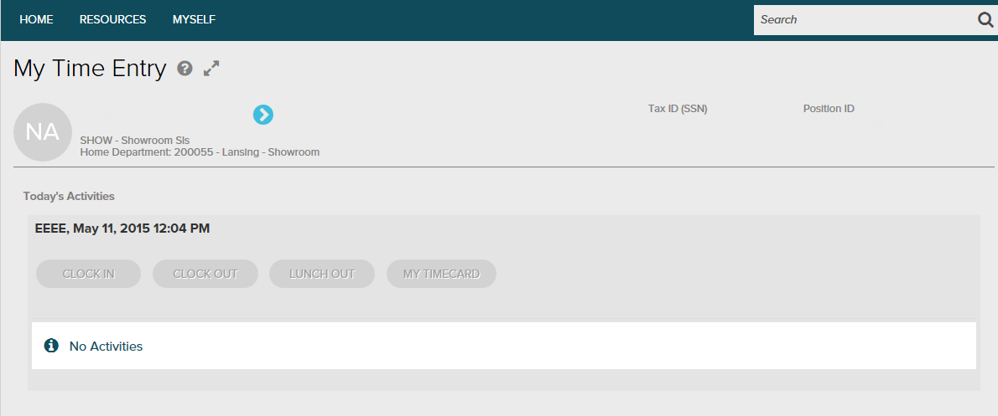

Timecard View example
