**Time and Attendance Supervisor “First Day” Guide**

1. **Go to** [**https://workforcenow.adp.com**](https://workforcenow.adp.com)
2. **Click on User Login and enter your current User ID/Password, then click Login**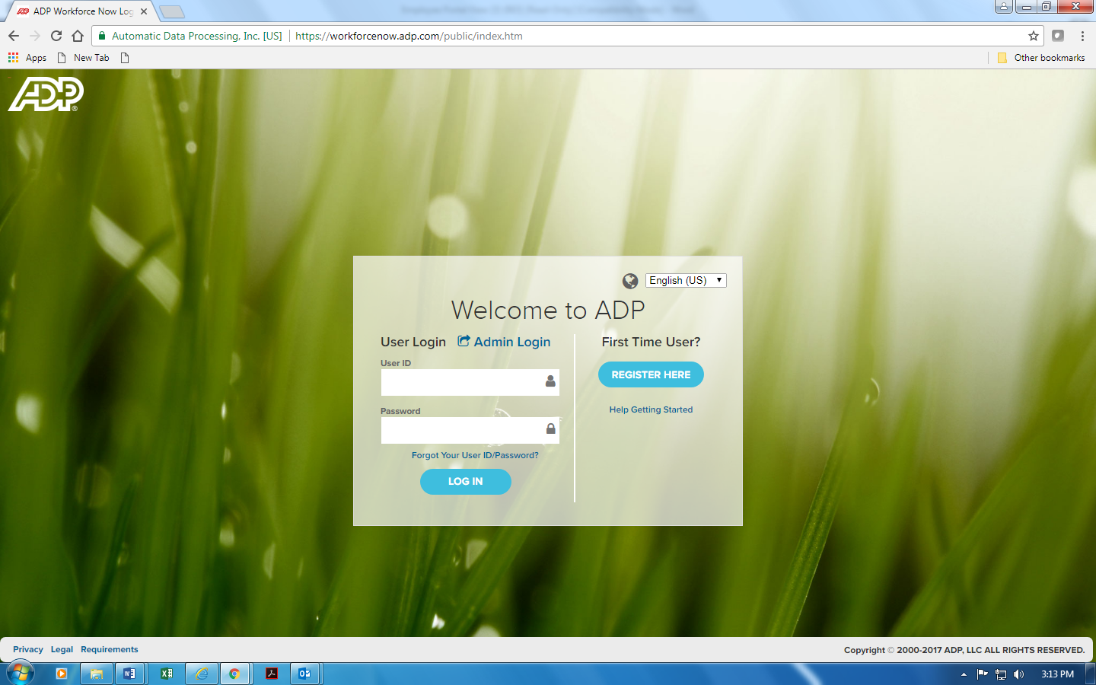

You will be brought to your company’s Home screen. *(Screen may look different due to your company’s preferences)*

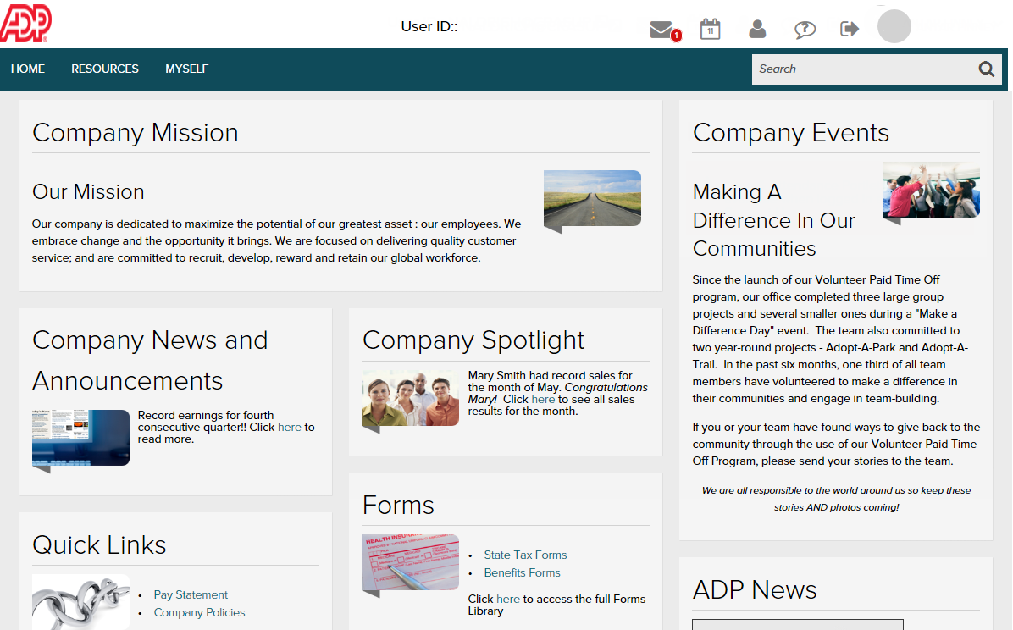

1. To view/approve your employee time cards, click on the **My Team** tab –Click on **Time and Attendance** and then **Individual Timecard.**

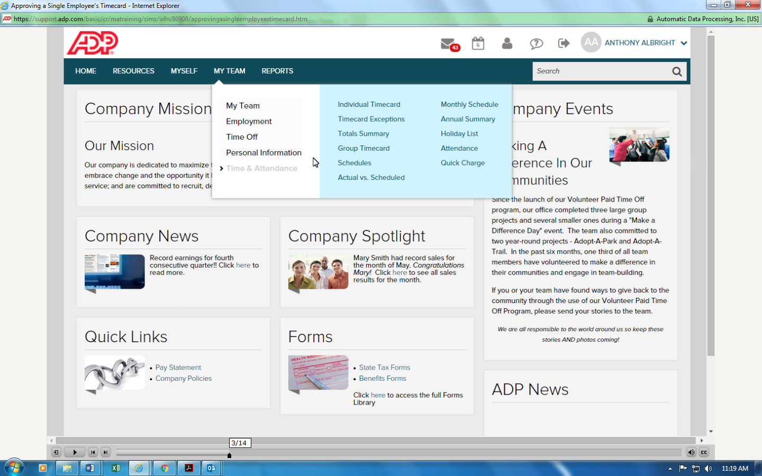

1. Click on the right arrow at the very top of the page (to the left of the employee’s name)

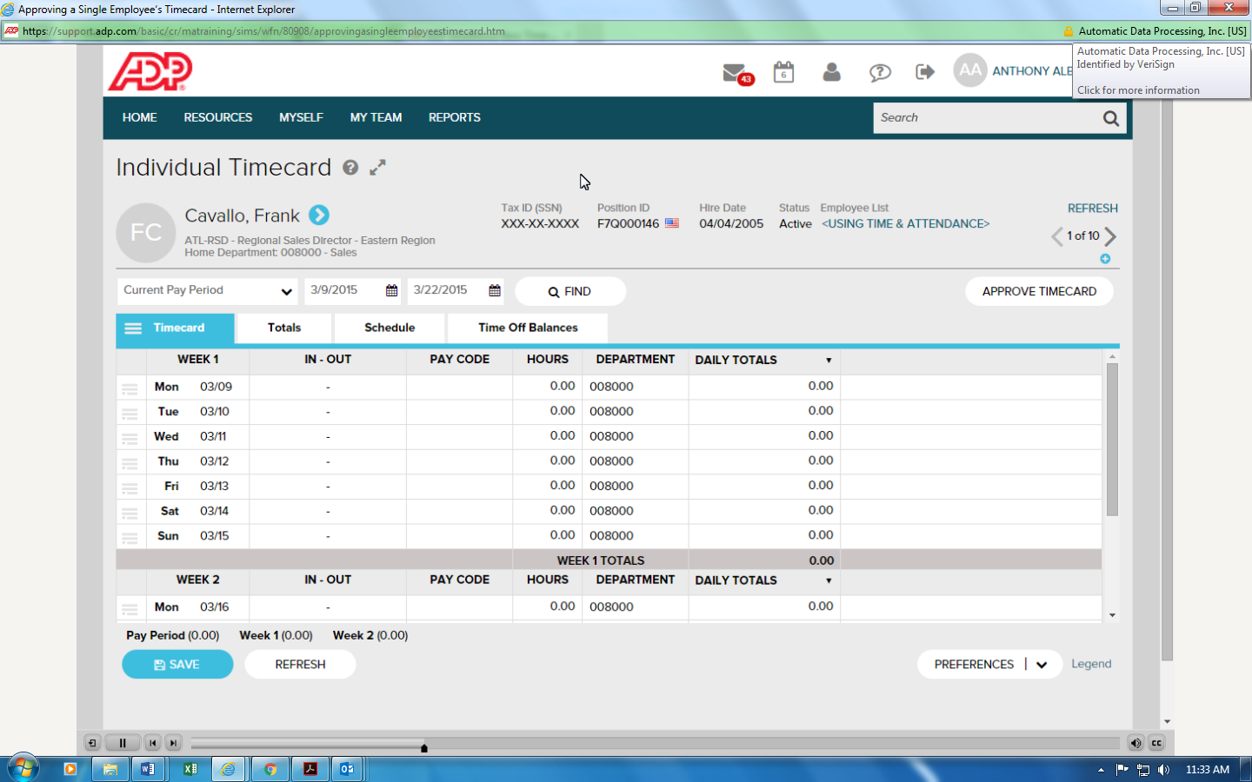

1. Under **Learning Bytes**, click “**Approving a Single Employee’s Timecard”** to watch a short tutorial that shows you step by step how to approve your employee’s timecards (this video is less than 2 minutes).

