Bone Marrow Registry Drive
Friday October 27th 11:00am – 2:00pm
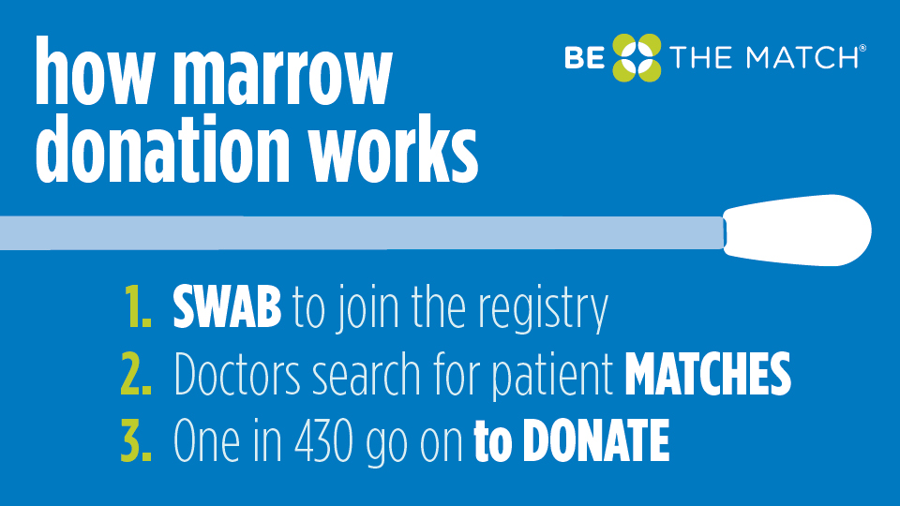
Location: Niagara University in the Gallagher Center
The registration process takes about 15 minutes
Donors must be within 18-44 years old

Hosted by: Be The Match Volunteer Chloe Hirschfelt
Any questions regarding the drive, bone marrow donation, etc.
chloejoycehirschfelt@gmail.com

