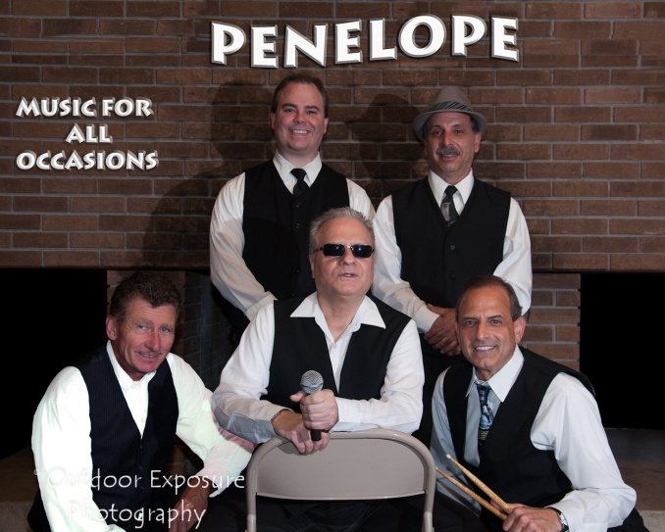
Friday
December 8, 2017
5:00 – 8:00 p.m.

Live music by PENELOPE
Dance the night away!

CAM’s Holiday Bash is FREE
for Castellani Art Museum members,
NU students, staff and faculty.
Admission is $10 for the general public.

Admission includes free refreshments,
cash bar, live music, raffles and prizes.
For more information call 716-286-8200

www.castellaniartmuseum.org

