Niagara University Study Abroad
Nederlands / Nieuw York
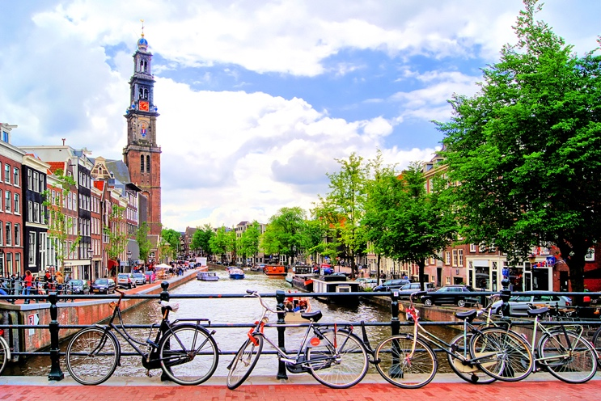

Key Information:

Saturday, March 9 to Saturday, March 16, 2019

Visit key museums and historic sites to understand Dutch influence on New York.

Bookings by ANGLO Educational Services, UK company specializing in student travel.

Hotels near city center at reasonable rates, breakfasts included. Not hostels or 5 star.

Coach transfers between airports and hotels, plus between cities.

Local transit passes, ride the NS like a local.

No course registration required; option to take HIS 272 simultaneously.

Trip leaders have lived in the Netherlands, basic Dutch language skills.

Not the usual tourist traps but the real Netherlands.

Connected to NYS Learning Standards, great photos and resources for your classes!

Cost:
Approximately $2200.00 per student. Includes: airfare, bus to Toronto airport from NU, hotels, museum admissions, breakfasts, most local transit costs.
Not covered: lunches and dinners, souvenirs, some local transit, additional entertainment (voetbal match, canal cruise, etc.). Estimate $450 spending money.

$300 deposit due by October 29th; additional $700 due by January 10; balance due by February 20th. Payable to Niagara University via Student Accounts.

Itinerary:

Saturday, 9 March: afternoon bus from Niagara University to Toronto Airport,
flight to Amsterdam.

Sunday, 10 March: arrive Amsterdam, bus to hotel, Amsterdam City Museum. Possible bike tour.

Monday, 11 March: National Maritime Museum, Tropenmuseum.

Tuesday, 12 March: visit Rijksmuseum, tour city.
Afternoon bus to Rotterdam, visit Delfshaven, Pilgrim Fathers Church.

Wednesday, 13 March: train to Den Haag, visit Maritshuis;
return stop in Delft, visit Museum Prisenhof.

Thursday, 14 March: bus to Arnhem, visit Airborne Museum, walking tour of city.

Friday, 15 March: train to Nijmegen, visit Het Valkof Museum. Optional meeting with teacher education faculty at HAN (Hogeschool van Arnhem en Nijmegen).

Saturday, 16 March: bus to Schiphol Airport, return to Toronto. Bus to Niagara University, arrive by that night.

Extra Details:

Be ready to walk.

Get up early and see things.

Travel light—Dutch dress is somewhat casual, jeans and shirts.

It will rain: good waterproof jacket and sturdy shoes.

Food is relatively inexpensive, but drinks aren’t. Lunch out of Albert Heijn.

Most Dutch people speak English, and there are many expats. Practice with Babbel.

Must have clean student conduct record to join trip; see me if you have questions.

Amazing country with friendly people, efficient transit, and generous hospitality.

