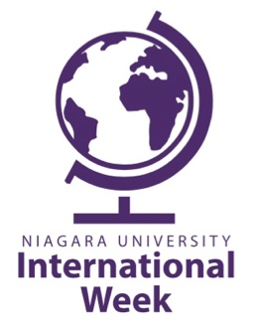

Schedule of Events
Monday, Nov. 12  11am – Gallagher Center  Make-A-Monte  Students can stuff their own Monte the Eagle mascot - $5  5pm - Gallagher Center  NU Basketball Tailgate Party  Games, food, green screen photos, and street signs. Come join some visiting international high school students as we take on rival St. Bonaventure!  8-11pm – Bisgrove, Room 350/351  International Karaoke  The stage is yours! Feel free to rock it in your own style – solo or with friends – supported by our international cheerleaders. Food will be provided! | Tuesday, Nov. 13  12-1pm – In front of Multipurpose Room, Gallagher Center  Food Around the World  The offer of food is the offer of friendship. Students from countries all over the world will share their home-cooked dishes with the Niagara University community.  Wednesday Nov. 14  11-2pm - In front of Multipurpose Room, Gallagher Center  Study Abroad Fair  Come explore all of the different opportunities that NU offers to go abroad! There is something for everyone! | Thursday, Nov. 15  6-8pm – St.Vincent’s Hall, 4th floor  Thanksgiving Dinner  Let’s eat, drink and give thanks together! All international students are invited to attend. The perfect time to count the many blessings in our lives!  For more information,  please email: international@niagara.edu or visit: www.niagara.edu/international

