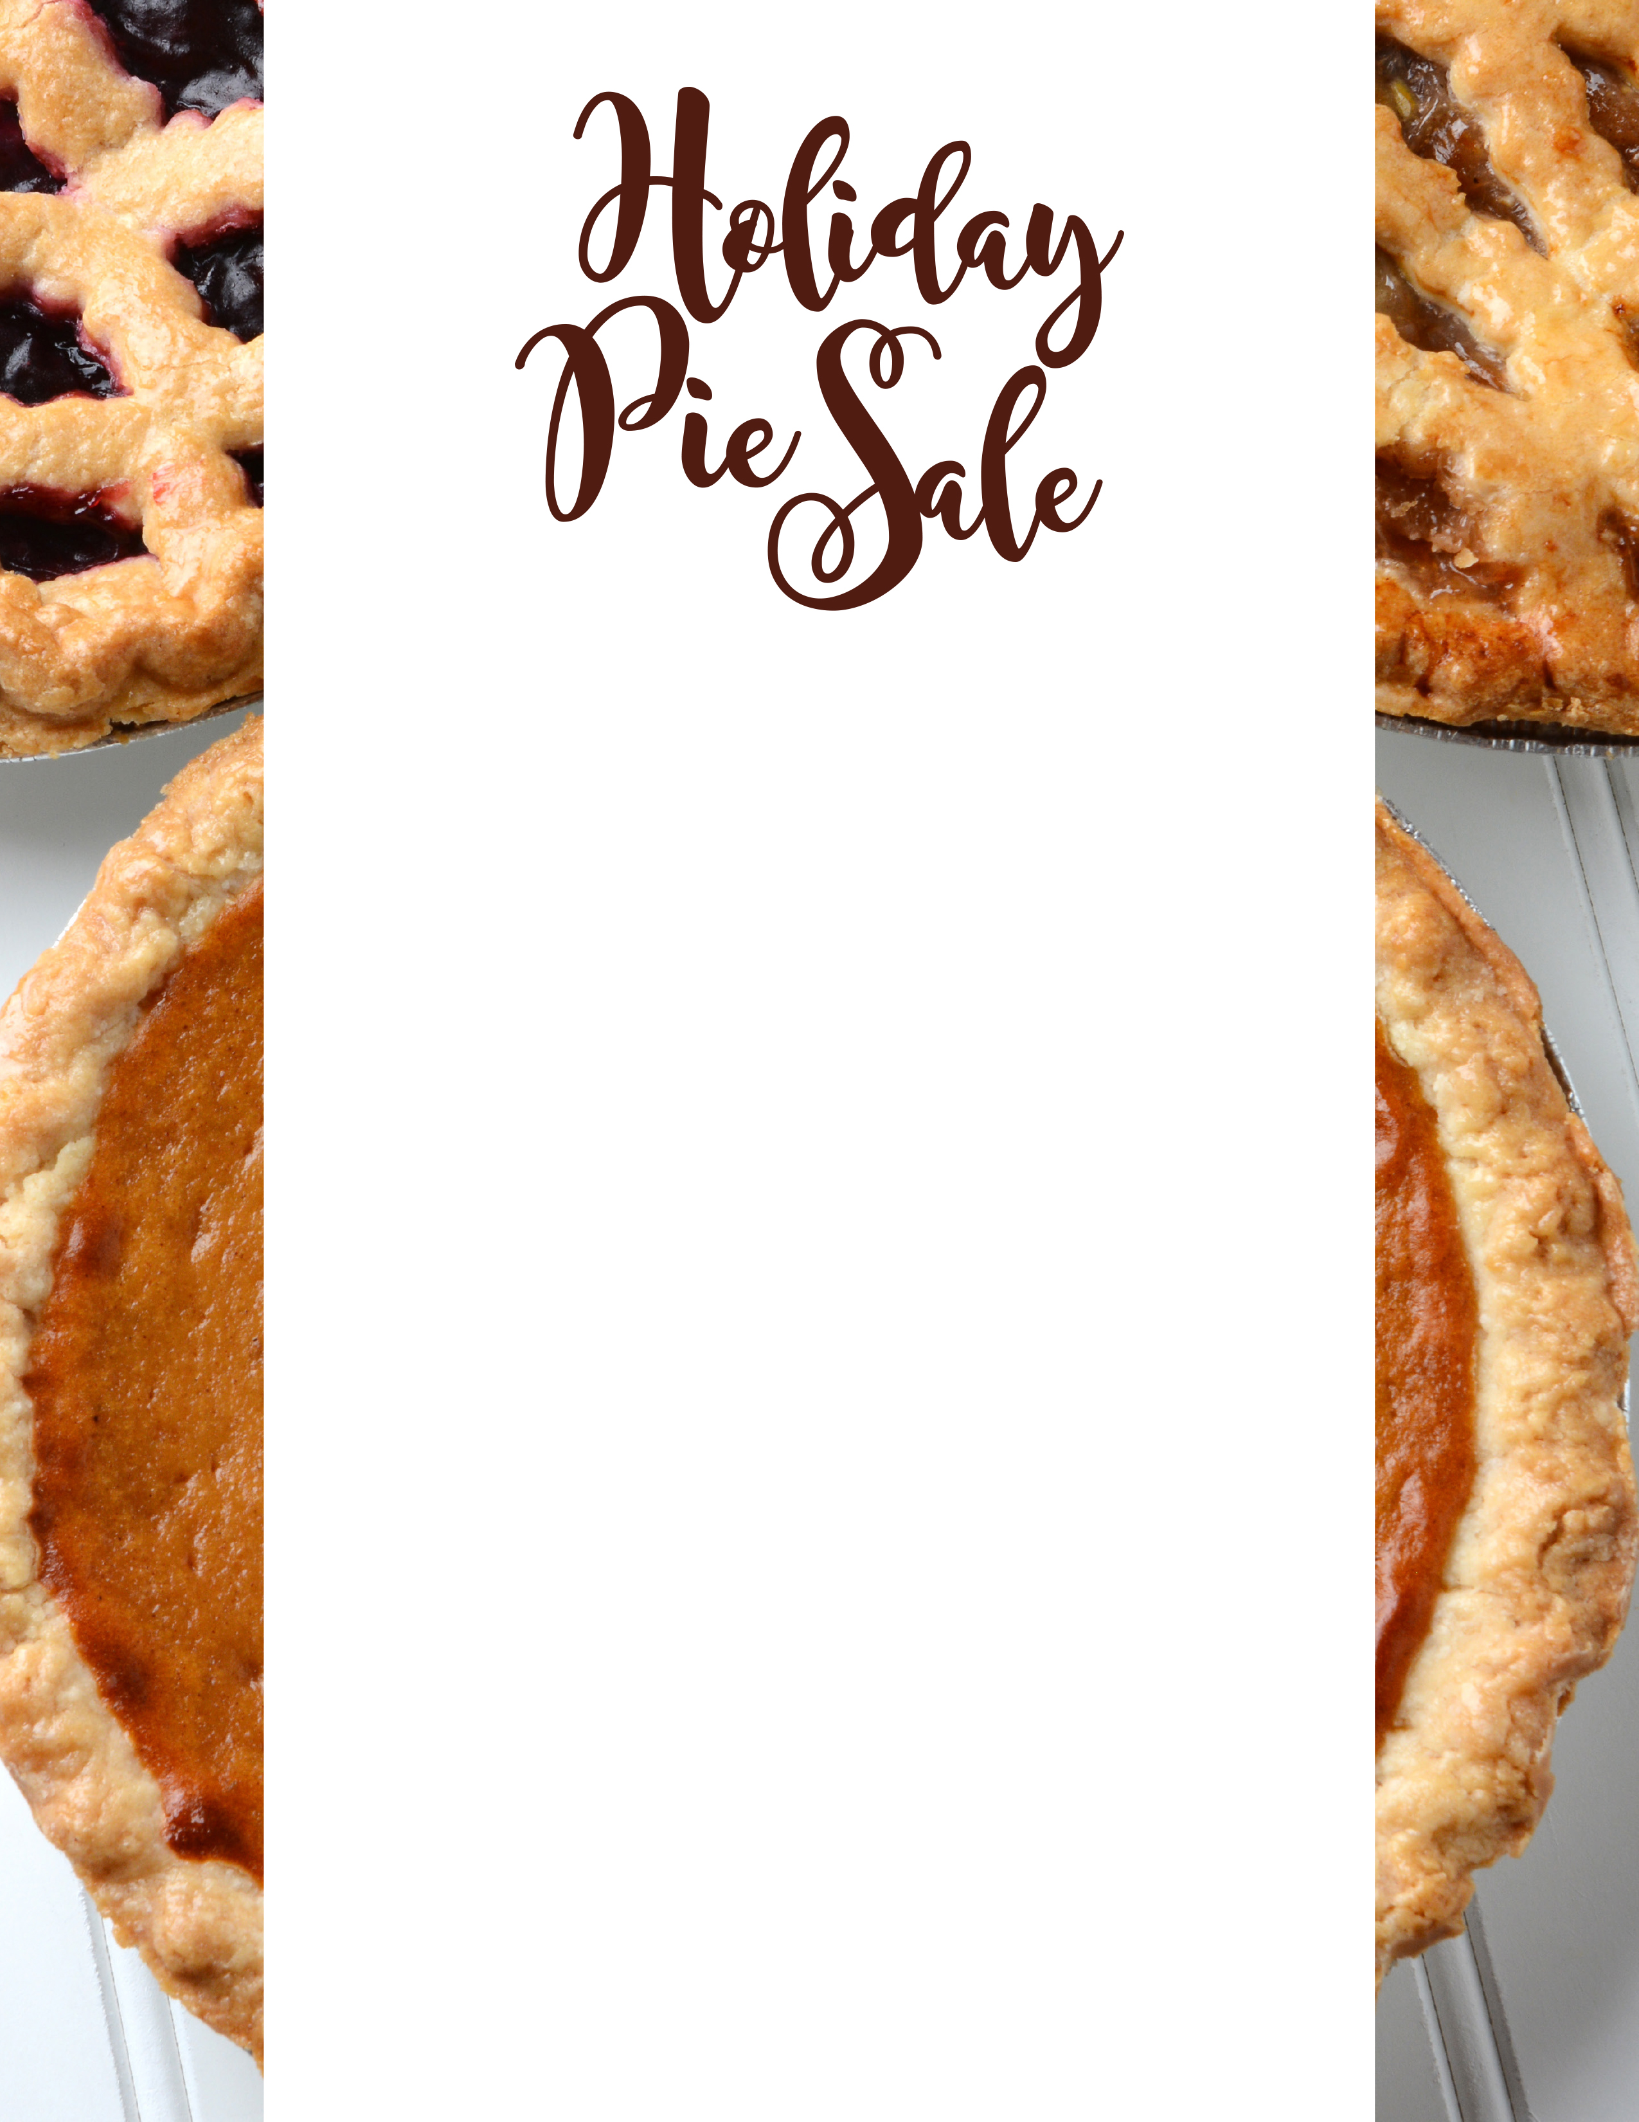

**Name:________________ Email: ________________**

**Date: November 1st**

**Payment and Submissions Due*: November 12th**

**Pick up: November 16th**

**Email your order to:** [**mszychowski@niagara.edu**](mailto:mszychowski@niagara.edu)

**\*Payments can be made to the front cashier in the Dining Commons**

**Or fill out the form below and give it to the cashier at the front desk in the dining commons:**

**Pies: $8.00 Quantity**

**Dutch Apple ___**

**Pumpkin ___**

**Sweet Potato ___**

**Pecan ___**

**Chocolate Cream ___**

**Total: ___**

**Cheesecake (Plain) $12.00 ___**

**Total: ___**

**Amount Due: $ ____**

All proceeds will be donated to the Adopt-A-Family program of Niagara Falls.