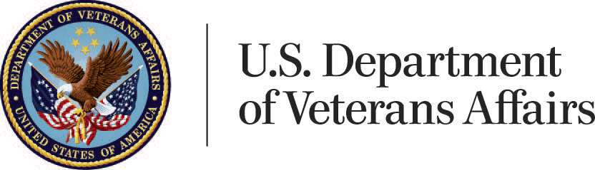

The Buffalo Regional Office

Proudly Presents the

**2019 SPRING G.I. BILL**

**75th ANNIVERSARY TOUR**

The Mobile Vet Center will be on present on campus with VA representatives on hand to answer your questions and provide information about:

-Veteran Education Benefits -Colmery Act / Forever G.I. Bill

-G.I. Bill -VET TEC -STEM

**April 11, 2019 from 9am to 3:30pm at Niagara University**

**April 24, 2019 from 9:00am to 3:30pm at Buffalo State College**

Contact your school Veteran Representative for more information.