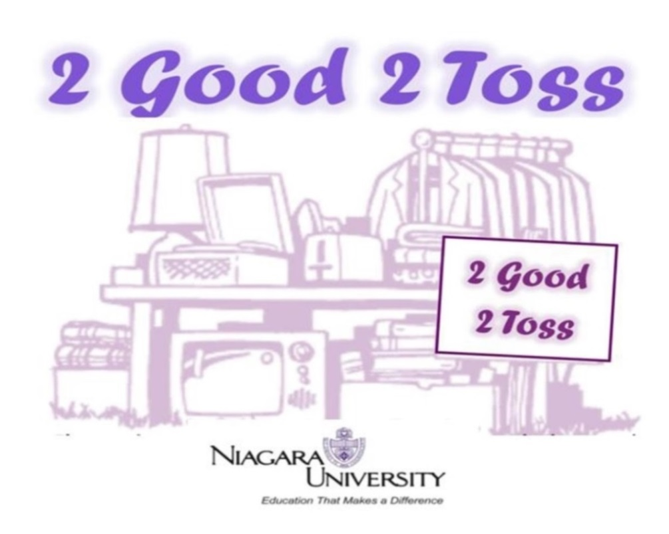

**Recycle, don’t discard!!**

Donate clean, usable items in good condition.

*No food, undergarments, pillows, or mattresses, please.*

**Bring your items to O’Shea or Seton lobby or to one of the storage pods on campus between May 3-May 20.**

Donated items will be sold at NU’s 7th annual   
Community Garage Sale,   
**Wed.,** **May 22, 9:00 am-1:00 pm,** in the **Kiernan Center**.

All proceeds will benefit Campus Ministry / St. Vincent DePaul Society.

*Thank you to ABF Freight for donating storage pods.*

The university is accepting and selling donated goods for this charity event and is not responsible for the condition of items purchased. Thank you for your understanding.