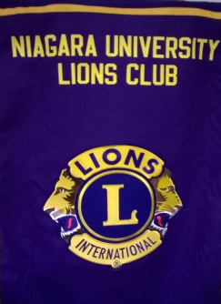
Please support the Niagara University Lions Club fundraiser by eating at Denny’s,
8020 Niagara Falls Blvd., Niagara Falls, NY,
Monday, September 30, 2019,
from 4:00-9:00 pm.

