|  |
| --- |
| When?  March 23rd, 30th  April 6th  from 4:30-5:30  FAMILY LITERACY CENTER  Enrichment Book Club Program (grades 3-8)  *Research confirms that student motivation is a key factor in successful reading. Book clubs can be an excellent venue for building excitement and friendship over good books. The small group setting will invite children into active learning and provide them with opportunities to speak, interact, and exchange points of view.*  Where?  The Family Literacy Center is located in Bisgrove Hall/  Academic Complex Room 125 |

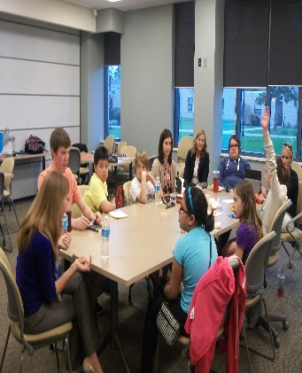

Pairs literature with discussions and activities

Every child receives a free book!

Provides a fun, engaging, and motivating book club.

What the program has to offer:

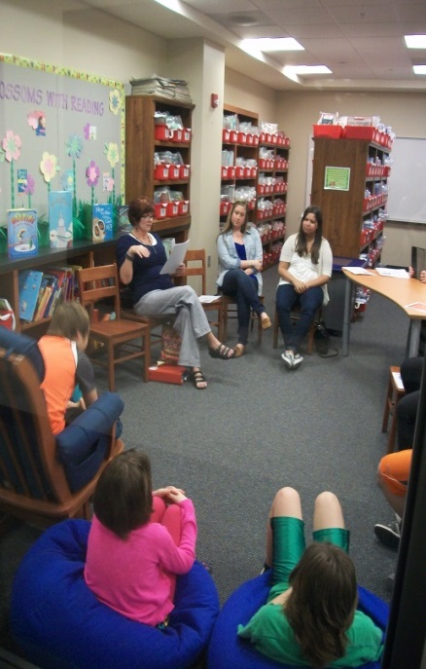

***To register or for more information, please contact Dr. Kathleen McGrath at (716) 286-8496 or email*** [***flc@niagara.edu***](mailto:flc@niagara.edu)