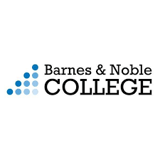
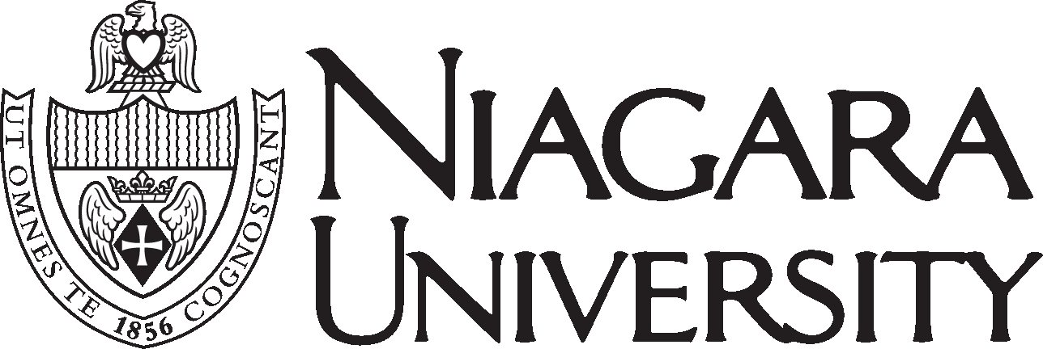

Introducing
First Day Complete

Dear Faculty and Staff of Niagara University:

We are excited to announce the launch of a new textbook program beginning Fall 2020. First Day Complete is an all-inclusive program which offers Niagara University students full access to course materials for one flat rate per semester. First Day Complete is an approach designed to provide students with all required course materials at the lowest cost and on the first day of class. Most textbooks will be considered rentals which students will return at the end of each semester. A benefit of this program is students will receive print or digital books depending on faculty selection.

This upcoming summer, students will be directed to place their orders online through the bookstore website. As orders are fulfilled, they will be available for in-store pickup or shipped directly to the students based on their preference. Included with First Day Complete, as an added benefit, most students will no longer need printed access code cards and will simply log into Canvas for access to publisher content.

Faculty will continue to use FacultyEnlight to research course materials and submit textbook adoptions. We will be sending out more information along with a FAQ page in a separate communication for the upcoming fall semester. In order to ensure student success is achieved in this model, book orders will be due no later than May 1st, 2020.

We are extremely excited to offer this program at Niagara University, as it allows us to provide students discounted, first-day-of class access to their required course materials. If you have any questions, please don’t hesitate to contact me.

Sincerely,

Jennifer Nagelhout
Store Manager
Sm749@bncollege.com
716-286-8595

