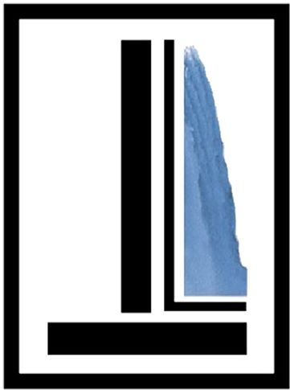
Independent Living of Niagara County
746 Portage Road • Niagara Falls, New York 14301
Phone (716) 284-4131 • Fax (585) 284-3230
www.wnyil.org/Independent-Living-Niagara

June 16, 2020
For Immediate Release
Contact: Ernest Churchwell
Public Information Officer
Office of Community Engagement
(716) 284-4131, ext. 181

International Disability Rights Leader to Address People with Disabilities in Niagara County

As they have for several years, for its annual Disability Pride community-wide festivities, Independent Living of Niagara County (ILNC) is celebrating the Anniversary of the June 22, 1999 Supreme Court “Olmstead v. LC” decision, which confirmed the Americans with Disabilities Act’s provision that people with mental health disabilities have the right to live in the least restrictive environment, that is, in our communities. However, this year, ILNC has a special guest speaker: International Disability Rights leader Judith Heumann will address the people with disabilities in Niagara County (via video conferencing) at 6:00 PM on June 25, 2020.

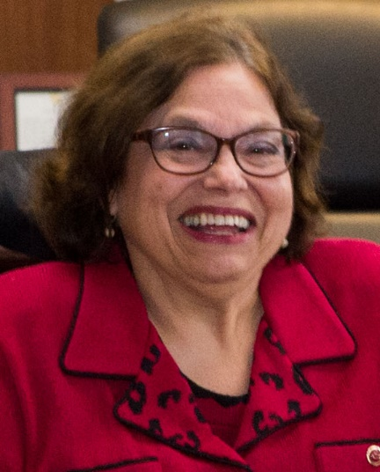
Just before this event, there will be two special viewings of the Netflix documentary “Crip Camp: A Disability Revolution”, the true story of Camp Jened in Hunter, New York, which served as the East Coast birthplace of the disability civil rights movement. Thereafter, former Camp Counselor Judith Heumann will lead a discussion on the current status of people with disabilities today, and what options we have at this point.

A wheelchair user, Judy had taken the New York City Board of Education to court in 1970, because she was denied a teaching position due to her mobility impairments; also, in that year, she founded Disabled in Action in the Big Apple. In 1974, while a legislative assistant to the chairperson of the U.S. Senate Committee on Labor and Public Welfare, she helped develop legislation that became the Individuals with Disabilities Education Act (IDEA). Additionally, she was: Deputy Director for seven years of the first Center for Independent Living in the nation, in Berkeley, California; a co-founder of the World Institute on Disability; the first Director for the Department on Disability Services of the District of Columbia; the Clinton Administration’s Assistant Secretary of the Office of Special Education and Rehabilitation Services at the US Department of Education from 1993 to 2001; the World Bank Group's first Advisor on Disability and Development, from 2002 to 2006. In 2010, Judy became the Special Advisor on Disability Rights for the U.S. State Department, appointed by President Barack Obama; also, from September of 2017 to April of 2019 she was a Senior Fellow at the Ford Foundation.

The ILNC’s Disability Pride celebration will take place over three days, providing individuals who RSVP the opportunity to view “Crip Camp” for free with a link at 6:00 PM on Monday June 22, and Wednesday June 24; of course, current Netflix subscribers can see it anytime. All are welcome to participate in Judy’s June 25^{h} wrap-up, via computer access or telephone, by contacting Jillian Moss at jmoss@wnyil.org to get the GoToMeeting online conference log-in information.

“CRIP CAMP”: CAMP JENED

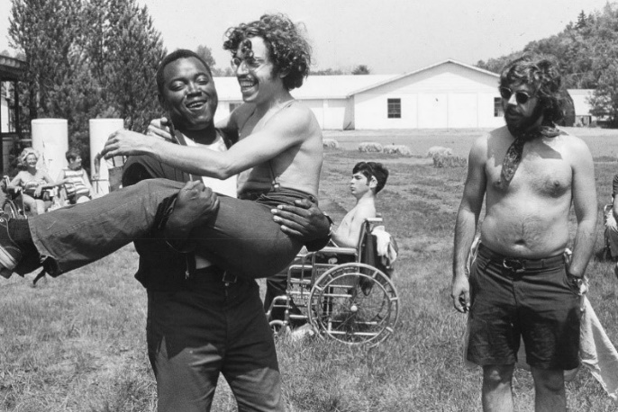
Established in the late 1940’s, in the Catskill Mountains, as a typical summer camp for individuals with polio, cerebral palsy and other disabilities, by 1970, Camp Jened had evolved into “a summer camp for the handicapped run by hippies”, says former camper and movie co-director James LeBrecht. Thanks to footage shot by then-15-year-old LeBrecht and a group of radical filmmakers, the People’s Video Theater, campers with disabilities who were accustomed to being rigidly controlled by family and institutions, can be seen experiencing “a utopia” with heretofore unknown respect and freedoms with limited adult supervision; perhaps, in-part, inspired by the 1969 Woodstock Rock Festival in nearby Bethel, New York.

Featuring Judith Heumann, James LeBrecht, Larry Allison, Denise Sherer Jacobson, and Stephen Hofmann, the film goes on to follow many of them as they unite with Ed Roberts and other former students with disabilities from the University of California at Berkeley to found the Independent Living Civil Rights Movement and its first agency, the Berkeley Center for Independent Living. It explores how fighting barriers and discrimination led to: Judy’s Disabled in Action shutting down a major New York City avenue to protest lack of subway elevators; the 28-day San Francisco Health Education and Welfare Office sit-in of 1977 that prompted HEW to finally sign the Rehabilitation Act Regulations; and, eventually, to years of work to pass the Americans with Disabilities Act of 1990.

Directed by LeBrecht and Nicole Newnham, and released under the banner of Barack and Michelle Obama's Higher Ground Productions, “Crip Camp” was an opening night selection at the Sundance Film Festival and 2020 U.S. Documentary Audience Award Winner there; it won the Zeno Mountain Award at the Miami International Film Festival, has a 100% Fresh rating on Rotten Tomatoes based on 80 reviews, and a weighted average of 85 out of 100 on Metacritic, indicating "Universal acclaim".

Independent Living of Niagara County is a member of the Western New York Independent Living, Inc. family of agencies that offer an expanding array of services to aid individuals with disabilities to take control of their own lives.

###
--

